Activity You Can Do With Your Child For Any Book!

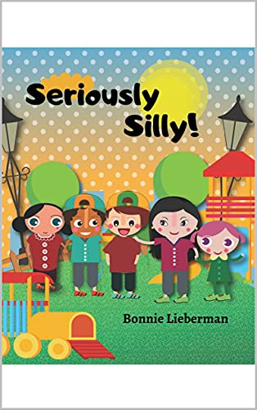 Let’s Think About What We Read- Label the emotion and tell the grown-up reading with you who was feeling that way and why?_______________________________________
Look at these pictures and talk about each picture as it relates to the characters in the story.
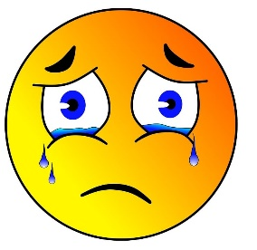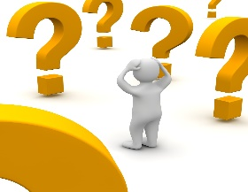
This Photo by Unknown Author is licensed under CC BY-NC-ND
_________________ _______________________________Have Fun! You are Awesome!

Who were helpers?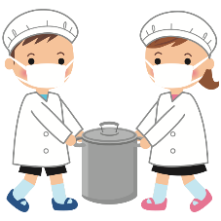 What was a funny word in the story? What do you think it means?

Tip was in a Spelling Bee. Can you spell a word that begins with b and ends with k?
Can you spell a word that rhymes with “silly”?
What does it mean to be kind? Who was kind to Tipper? Be safe. Be kind? Accept the differences in others. 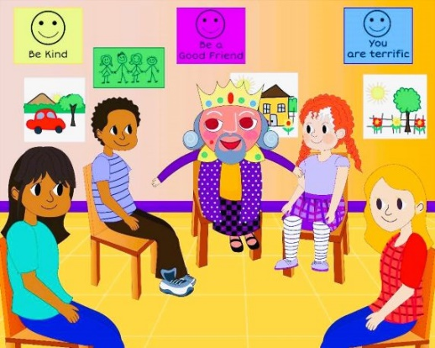How are the people in the
picture the same? How are they different?

